Clarification about Upcoming Adam Optimization Video

Please note that in the next video at 2:44, the following picture is correct. However, later in the video, the db^{2}*db*2 lost the ^{2}2.

The bottom right equation should be:

S_{db} = \beta_{2}S_{db} + (1 - \beta_{2})db^{2}*Sdb*​=*β*2​*Sdb*​+(1−*β*2​)*db*2

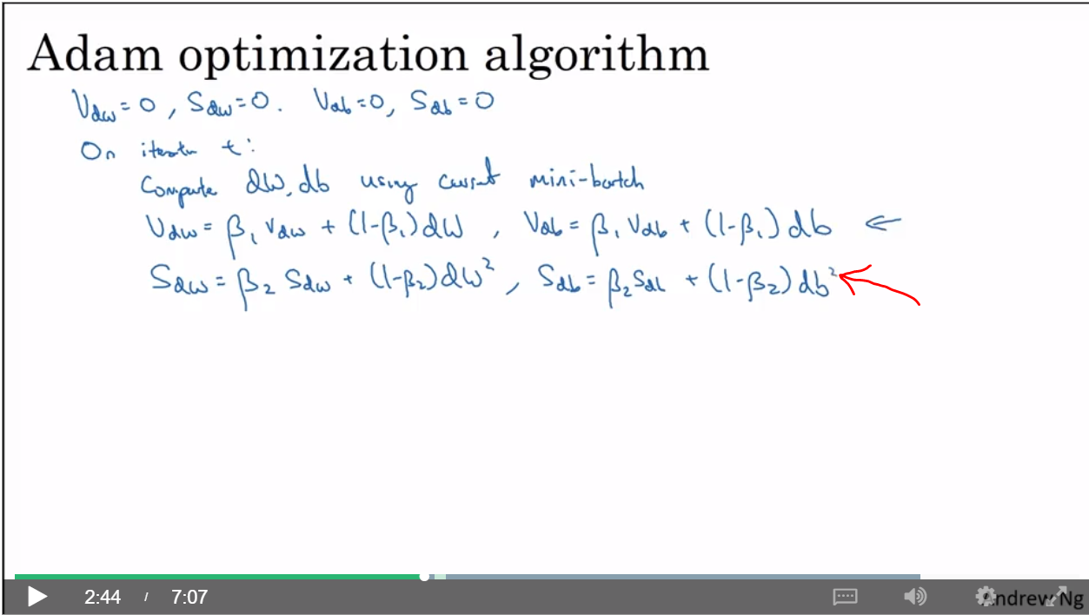

Clarification about Learning Rate Decay Video

Please note that in the next video, at time 3:35, the values for alpha should be:

Epoch 1: alpha 0.1

Epoch 2: alpha 0.067

Epoch 3: alpha 0.05

Epoch 4: alpha 0.04

The formula for learning rate decay is:

\alpha = \frac{1}{1 + decayRate \times epochNumber} \alpha_{0}*α*=1+*decayRate*×*epochNumber*1​*α*0​